

**Why do we partner with**[**Reclaim Our Vote**](https://u1584542.ct.sendgrid.net/mps2/c/_wA/ni0YAA/t.2xn/t2G4HgpBQraL39jGe2cngQ/h0/kZbvZtshYPIbVxj-2BULh7Kcl3z90MUIj5JTekzqllrSj-2FQ-2BHA110yxL4bHAKHDFl-2FumdQ3ai9hJWgF7hrr6-2FBkB12YwpvRA-2FkZpLzGxP5BjbLl0tyHGj6o0RJSHTPcuL9MF3t0tPNPNLz5zH1NYOqxMxJB74oYJKrZHKMhiUK05dWhb1lX7WqSZiOaemdtr39uYzctWtrxy53PgsV4sFNSDxJiABGEFuDayQcUuzq6YfiabaaS13D8IQfRda9nD98vDXxm34-2FDSQq-2Bnr0D1p6AhDEQdvIoXYxlznAsQLQHX3-2BrHM4WDSG4WsHzcfNagR19rO46-2BoncpLNXiqWcNjSWsU9H1YISKAv-2F3n-2Bpnw9rXU7WUAbS1UMJpvZVB61hBsYiz2d88dix5gR07UJpY6rodJuI6c5k9i65l4cFxS4wiVVyD4os-2FCTKqaktc9l-2FMdfG0OKlxyT6Y-2Fn-2BiNJILJmjA-3D-3D/rR3C)**?**

**It's simple -- with our help, communities of color can swing elections in 2020!**

* + Hundreds of thousands of voters of color have been purged from voter rolls, de-registered, and disenfranchised by gerrymandering and voter suppression tactics.
  + **Reclaim Our Vote** has a brilliant strategy for *directly engaging eligible voters of color* in swing states with long histories of voter suppression and with communities overlooked by conventional campaigns.
  + They've built powerful partnerships to leverage emerging opportunities and maximize outcomes --  **NAACP, Black Voters Matter, VoteRider, DemLabs, Mi Familia Vota**and others.
  + They understand the importance of building a lasting base ***within*** communities of color.
  + They know how to engage us (here in the blue Bay Area) in high quality, high impact "export" work -- canvassing, phone banking, texting, post carding and more.  They are volunteer-driven and nonpartisan.

**Join us -- learn how we can win in 2020!**

**Hear Andrea Miller**

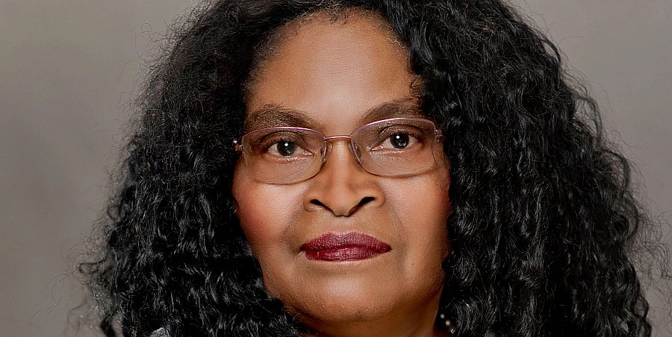 **Andrea Miller**is the founder of the **[Center for](http://centerforcommonground.org/main/?link_id=1&can_id=2a42a4ebba27fd312ffee9373bedbe2f&source=email-fight-voter-suppression-feb-4th-fundraiser-to-empower-voters-of-color-in-swing-states&email_referrer=email_685903&email_subject=fight-voter-suppression-feb-4th-fundraiser-to-empower-voters-of-color-in-swing-states)**

**[Common Ground](http://centerforcommonground.org/main/?link_id=1&can_id=2a42a4ebba27fd312ffee9373bedbe2f&source=email-fight-voter-suppression-feb-4th-fundraiser-to-empower-voters-of-color-in-swing-states&email_referrer=email_685903&email_subject=fight-voter-suppression-feb-4th-fundraiser-to-empower-voters-of-color-in-swing-states)** and leads its **[Reclaim Our Vote](http://centerforcommonground.org/main/index.php/campaigns/reclaim-our-vote?link_id=3&can_id=2a42a4ebba27fd312ffee9373bedbe2f&source=email-fight-voter-suppression-feb-4th-fundraiser-to-empower-voters-of-color-in-swing-states&email_referrer=email_685903&email_subject=fight-voter-suppression-feb-4th-fundraiser-to-empower-voters-of-color-in-swing-states)**

**[campaign](http://centerforcommonground.org/main/index.php/campaigns/reclaim-our-vote?link_id=3&can_id=2a42a4ebba27fd312ffee9373bedbe2f&source=email-fight-voter-suppression-feb-4th-fundraiser-to-empower-voters-of-color-in-swing-states&email_referrer=email_685903&email_subject=fight-voter-suppression-feb-4th-fundraiser-to-empower-voters-of-color-in-swing-states)**. Hear about Reclaim Our Vote's 2019

successes in Virginia and North Carolina, and the

plan for 2020 in key swing states, including Texas,

North Carolina, Alabama, Arizona, and others.  The

strategy is proven effective and scalable -- **your**

**donation will help build capacity for 2020!**

**Tuesday, February 4th, 6:00 - 8:00 PM**

**The Marsh Theater, 2120 Allston Way, Berkeley (near Berkeley BART and parking)**

[**TICKETS**](https://u1584542.ct.sendgrid.net/mps2/c/_wA/ni0YAA/t.2xn/t2G4HgpBQraL39jGe2cngQ/h5/CA0gLXQEKb6jqGkD7RqZidt8oaKWWGgFk1MXsRu-2B6-2BkV9ehLiAT86tIuUtZ1P-2F6YAFIXW933Af-2Fzvc9Kc04-2Fi8MnWS6sDhT6HhtrUapOMYEeuOaSHrZOMHcCNdbu-2ForTn87fVjgxiaGVaFAR36a1tFuACkSafHg6skh21pV0aDHj1G6Lv1abftgJj-2BOzFgS2GmDf2JeFO2nEG9CqC0vDEItpO-2BxlO5MmmhlzgwmafaVzoDZBJebEDRAF4UU-2BqMc6JPrHNEjCkG7QYYdeepukpaUyzdIhpO-2B6JmBwgVz4F5Xxmo-2BvGo5krqrkO58DUw1IslzDl7mrggO6qI17IraGuwK4aaWkEiGpmNWT5ITKg1Sic75o4pUwivXZm4jrNvxFXh9e3xqvTMEviOwQtLPMOauAOwqRuta5oP-2FBU-2F0nI6W5i8xcFchP4RBfUv5lHhmKzS-2FHzg-2FfUqJuTxPrr6EebSrfQ5WfiFhv3wUAB1dmnp-2F13C0EJt2WR129AZkkBeRz/7nf7)

***Can't come?***[***DONATE***](https://u1584542.ct.sendgrid.net/mps2/c/_wA/ni0YAA/t.2xn/t2G4HgpBQraL39jGe2cngQ/h6/hhRpZZW1RfrqdNP9De00vQRlUIk-2BKhU3wA9r6CKglNJcFBEIXOxGKJWorcSksVcqp7D1rNAJVr6N1vJhNTHkhq8jTLRekQ07i8RufGSZL1ZZJW2lhkr66-2FL4e4Ruo5vdLMhOPIN7BMI4byg00lkxJ2uGWIPuMUM1DdoxVrBf3ufP3JhSIXFtOjuw9Kjcv1WPt-2F7xsi5R9RsUOQxAhZuiW2Xp8sINSrlv85jaR5tqf4omFRC-2BB9Y3l1RVNeg7cKRN0vl7q-2BP3DkjLMRQk-2Bh2EFTK3cH-2F-2BperYXgLnyUnbmkmpgPkUOBRzFBNolFlPpSGR1kU8MUxKx1itb59-2F8h5TCyG7Co3f1D3h3jTrOYv3UY3QkoQqVKBVplwtA8cB-2F-2BRMe85WkLkq8smtQsWGvb-2BQOcBWwtJOzZJFb5AEuBJsQhsaLfKxg0viwLKvt55bVNVpaAyYXBo9OWtNcC6FT6029A-3D-3D/vvpb)

**Fundraiser co-sponsor organizations**

**Commit to Canvass - Commit to Flip Blue - East Bay Activist Alliance - Indivisible Berkeley Voting Rights Team - Indivisible East Bay - Indivisible Elmwood - Indivisible Thousand Oaks - Phone Bank Coalition - OFA Berkeley+Central Valley - RAEB - Together We Will Albany/Berkeley - Unitarian Universalist Church of Berkeley (Kensington) – Mi Familia Vota**